SURFRIDER PACIFIC RIM - STRAWS SUCK CAMPAIGN PACK
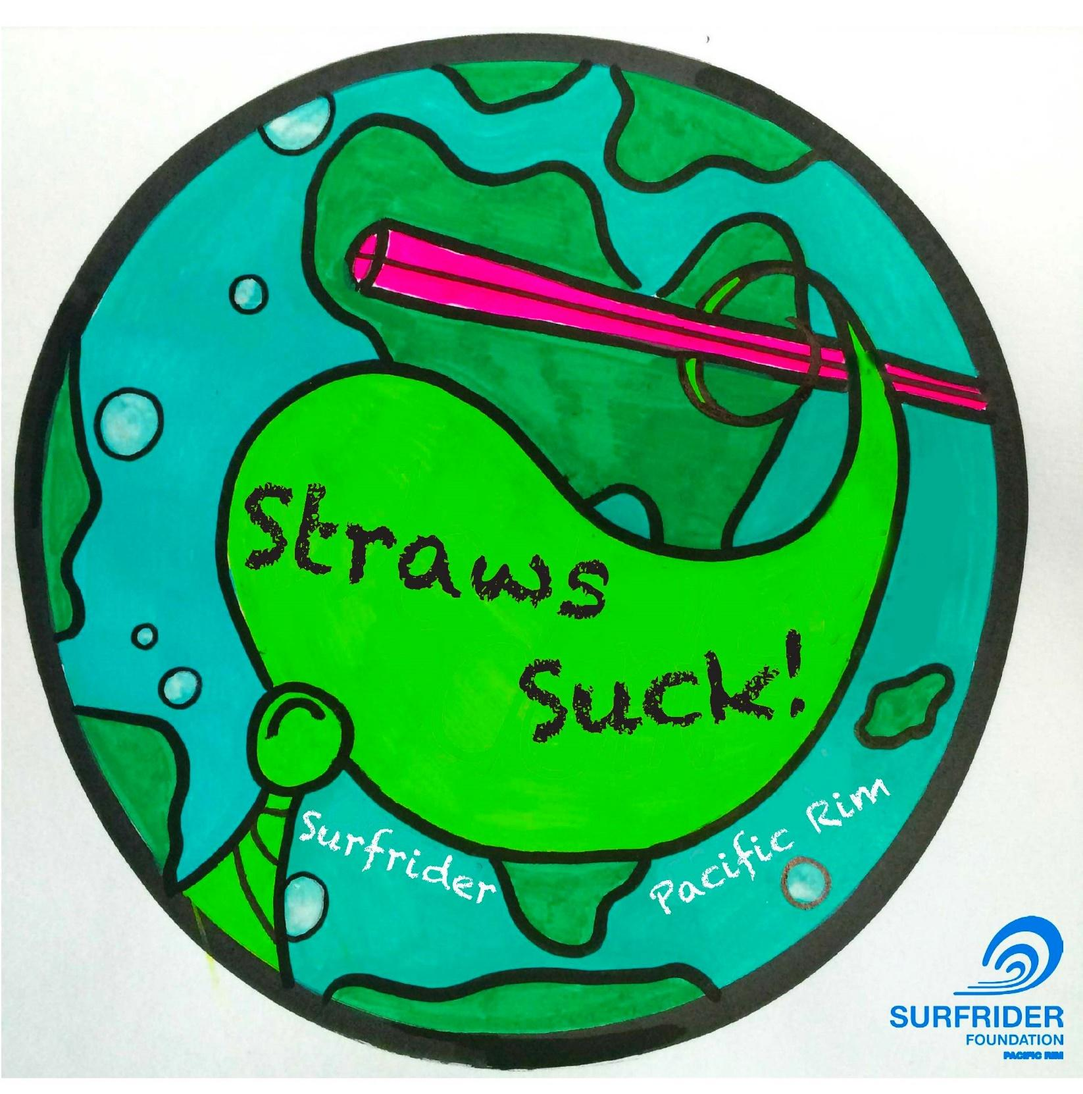

Preliminary Steps
- Create a document with ALL of the possible establishments that have straws including restaurants, hotels, cafes, juice bars, coffee shops, ice cream shops, food trucks, grocery stores, banks, gas stations. Find an email address or a contact number for each business, if possible the manager/owner/food & drinks manager.
-pick a timeline for the campaign to run, with a significant campaign end date for businesses to join by. For example, we challenged the business to do this by EARTH DAY, April 22nd, 2016. That way businesses can market themselves too. Think of a date that your town would jive with.
- Be clear on your request. Eliminate plastic straws; switch to reusable straws or paper straws UPON REQUEST ONLY.
- Find suppliers for reusable or paper options, with various price ranges to suit. In North America, Aardvark Straws and Green Munch supply compostable straws, the point is MAKE IT EASY for business to switch to a new supplier.
- Create a cool campaign poster with a catchy logo/art and start advertising EVERYWHERE
- Get in touch with the local chamber of commerce or tourism board and ask for their support
- Connect to your local radio and ask them to support the campaign and do an interview with them with the challenge “We are challenging the city/town of XXXX to eliminate plastic straws by World Ocean day XXXX 2018”

Launching the Campaign!
- Use the STRAWS SUCK Surfrider logo or campaign name, and hashtag everything about the campaign on social media #strawsSUCK or create your own logo, offer to advertise business that sign up on your website, reward them with a certificate if they eliminate plastic straws.
- Go door knocking on all businesses, and talk to them about the campaign, let them know the associated environmental pollution (see plastics facts below and Volunteer Guideline).
- Send an email to all of those businesses using the template below, keep it friendly!
- Once you have business interest, get them to sign a pledge (see sample below) and then highlight to other businesses that this business has signed up already….make it known that this is a popular move to make!
-You can instruct businesses to order paper straws through Greenmunch.ca, as well as Aardvark Straws.
-FUN TIP: You can also getting business to tag and challenge each other on social media, which was a big hit for our campaign.
-IMPORTANT TIP: Get data for how many plastic straws business use!!! SUper important to be able to show environmental impact at later stages

Media to Magnify Efforts
- Contact as many media contacts as possible, local paper, magazines, online global papers like Huffington Post. Someone will bite and do an interview, and include an interview with a business who has signed up. Let business know they are receiving media attention if they sign up.
- CREATE a goofy video with business that sign up like ours!
- Get local business to LIKE YOU…listen to their story, highlight what they do awesome at, ask for their solutions. Make business feel AWESOME about the campaign. Give them a certificate when they sign up (sample attached) , take their photo and publish on social media.
- Once you have enough businesses signed up, make a presentation for your local Mayor and Council, take in all of the signed voluntary business and ask them to enforce a BAN.

Email TO BUSINESS sample;
Thank you for your consideration for committing to going plastic straw free! You were recently visited/emailed by volunteers, and I write to ask if I can help support you putting this into action! The STRAWS SUCK campaign invites all business to stop giving out plastic straws entirely, and to only give out compostable options on request to customers who ask specifically for a straw. We are challenging business to join the campaign and be plastic straw free by XXXXXXXX

The campaign has already been successful in many parts of the world including British Columbia, Miami, London, San Francisco. This is a perfect opportunity for XXname of businessXXX to be part of that. I am here to provide business with the support, education and resources to help you go straw free.

FAQ & Solutions
How many plastic straws do you already have onsite? How long do you think it would take to use them? Can they be sent back to your supplier for a credit? Can they be sold? Can they be used for anything else at all (wedding cake tiers!) Are they recyclable? Can they be donated for craft projects to raise awareness? Can you agree to stop using your plastic straws by XXXXXX

Resources for compostable options; Does your existing straw supplier sell a biodegradable option? Can your existing straw supplier swap out your existing plastic straws for biodegradable options. XXXADD LOCAL SUPPLIER OPTIONSXXXX

How to move forward? Have a staff meeting, or send an email to all staff with the plan to remove all plastic straws. Set a date. Let all staff know that straws will no longer be given out UNLESS REQUESTED. Remove your straws from the bars and counters. Mention in any new drinks menus that you are a SURFRIDER supporter (we can send you our logo) and therefore you will no longer be serving any plastic in drinks, its a positive marketing angle for your business. .
If you would like to talk more, or to join the campaign, drop me an email and let us promote your business being plastic straw free! Let’s do this as a community, and then let the world know that XXXX is plastic straw free!

Thanks for your time, please write back with any questions!

Resources:
thelastplasticstraw.org
surfrider.org
5gyres.org
plasticpollutioncoalition.org
http://www.greenpeace.org/international/en/campaigns/detox/what-you-can-do/No-Plastic/
plasticoceans.org

Straws Suck Campaign Volunteer Guideline
Share this with volunteers who will be supporting the campaign!

History of Campaign in the Pacific Rim
41 businesses, 9 million hits, and many strawless cocktails later, Straws SUCK has become a sensation in the Pacific Rim. This campaign was launched in Tofino in early 2016, and by Earth Day on April 22nd, 41 businesses had eliminated plastic straws. Now, Ucluelet is ready, with many businesses who have already given up plastic straws once hearing about the movement.

So, last month, we launched Straws SUCK Ucluelet, and could not be more excited! Our goal is to assist businesses in eliminating single use plastic straws. We will be working with them to completely eradicate straws, or transition them to using paper straws upon request.

The following guideline includes best practices to follow in training volunteers to work with businesses in assisting them to eliminate single use plastic straws. Please change the specifics of the details to reflect your organization or effort!

Step 1: Contacting Business
Each one of you will have 5 businesses to work with. You are welcome to email or call the business manager first to set up a time when they are free, we want to avoid talking to a business when they are extremely busy and can’t offer their full attention. If you are unable to email or call them, or would rather go in person, ensure you go outside of peak hours, and ask the manager if they are available. Introduce yourself, and state that you are volunteering for Surfrider Pacific Rim’s Straws SUCK Campaign.

Step 2: Explain the Campaign
There’s a great quote by Canadian writer Thomas King, “the truth about stories is, that’s all we are.” We are all made up of narratives, and we are able to connect to a campaign when it’s presented as a story that we can relate to.

Ask them, do they know about Surfrider Foundation? What do they know about us?
-Provide some information on the organization, our mission is the protection and enjoyment of the ocean beaches and waves! Living here on the coast, one of our biggest programs is the Rise Above Plastics Program, working to eliminate single use plastics and implementing progressive recycling practices!
-Use this as an opportunity to get to know the organization, do research, read the website, talk to the Chapter Manager about anything you’re wondering about.
-If they know tons about the organization - great! You won’t have to explain so much. They might not be feeling talkative, so use your intuition in explaining.

As part of our RAP Program, we have the Straws SUCK Campaign, which is part of a global movement to eliminate single use plastic straws. Ask, what do they think about plastic straws? How do they feel about their impact on the health of marine ecosystems?

Give some power facts:
-Straws are one of the top ten plastic items found in the ocean.
-It is estimated that McDonalds alone uses at least 60 million plastic straws daily, worldwide.
-Plastic doesn't biodegrade, it photodegrades into smaller and smaller pieces, which gets ingested by marine and land animals, and into our food chain.

Ask them, how do they feel about that? Why does ocean protection matter to them?

Emotional Rollercoaster
Give good news! A good pitch follows the “emotional rollercoaster”, which brings the listener back up and feeling good!
This can include:
-Municipalities all over the world are eliminating single use plastics, from Alaska to Kenya!
-There is a whole movement, that has already reduced millions of straws from entering the environment, and by joining, we will make plastic straws relics of the past!

Of course, feel free to make it personalized as long as it fits in line with Surfrider’s attitude of positivity and being proactive. Why is rising above plastics important to you? Why do you want plastic straws eliminated? Maybe you plan on having a family, or you love sea creatures, are you an avid surfer? Do some reflection. When we talk from the heart, people can see this, and begin to identify why it’s also important to them!

Tips:
Use positive, inclusive language “I know we can do this!!” “The steps we are making are going to be so beneficial to the community of Ucluelet, and the Pacific Rim at large” “Thank you for being part of the movement to Rise Above Plastics”

Step 3: Give Resources
Once the business is on board, provide eco-friendly alternatives to them, which are stated below. We also need to get an estimate of plastic straws they are going through in a month or year, this is going to help us calculate the total impact at the end of the campaign.

→ NO STRAW
→ PAPER STRAW
→ REUSABLE STRAW

Step 4: Provide Marketing Materials
Upon success, provide each business with a Straws Suck certificate, and do a photo op with them for social media that will be released on April 22nd, Earth Day 2018! Let them know we want to celebrate their massive achievement in helping Ucluelet to be plastic straw free. This will be fun, and will help bring positive attention to their business.

Step 5: Follow Up With Business
Once the business has received paper straws - or eliminated straws all together, check back in and see how they are doing. We want the business to know that we are still with them and supporting them after they’ve completed the action of eliminating plastic straws. To ensure longevity of the change, ask, what challenges have they been facing? Are they still only giving out straws upon request? What can we do to support them? How will they ensure plastic straws do not re-enter the business when new staff, manager, owner, buyer comes on board?

Let them know about all of the other campaigns and programs we are working on, we want them to stay involved! Remember, “Let’s end the consumption of single use plastic, starting with straws, and leading to other products like bags, utensils, and plastic bottles.”Again, congratulate them, and let them know how stoked you are that they have made such an incredible change.

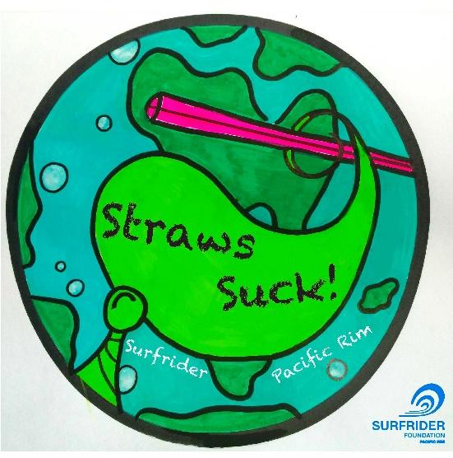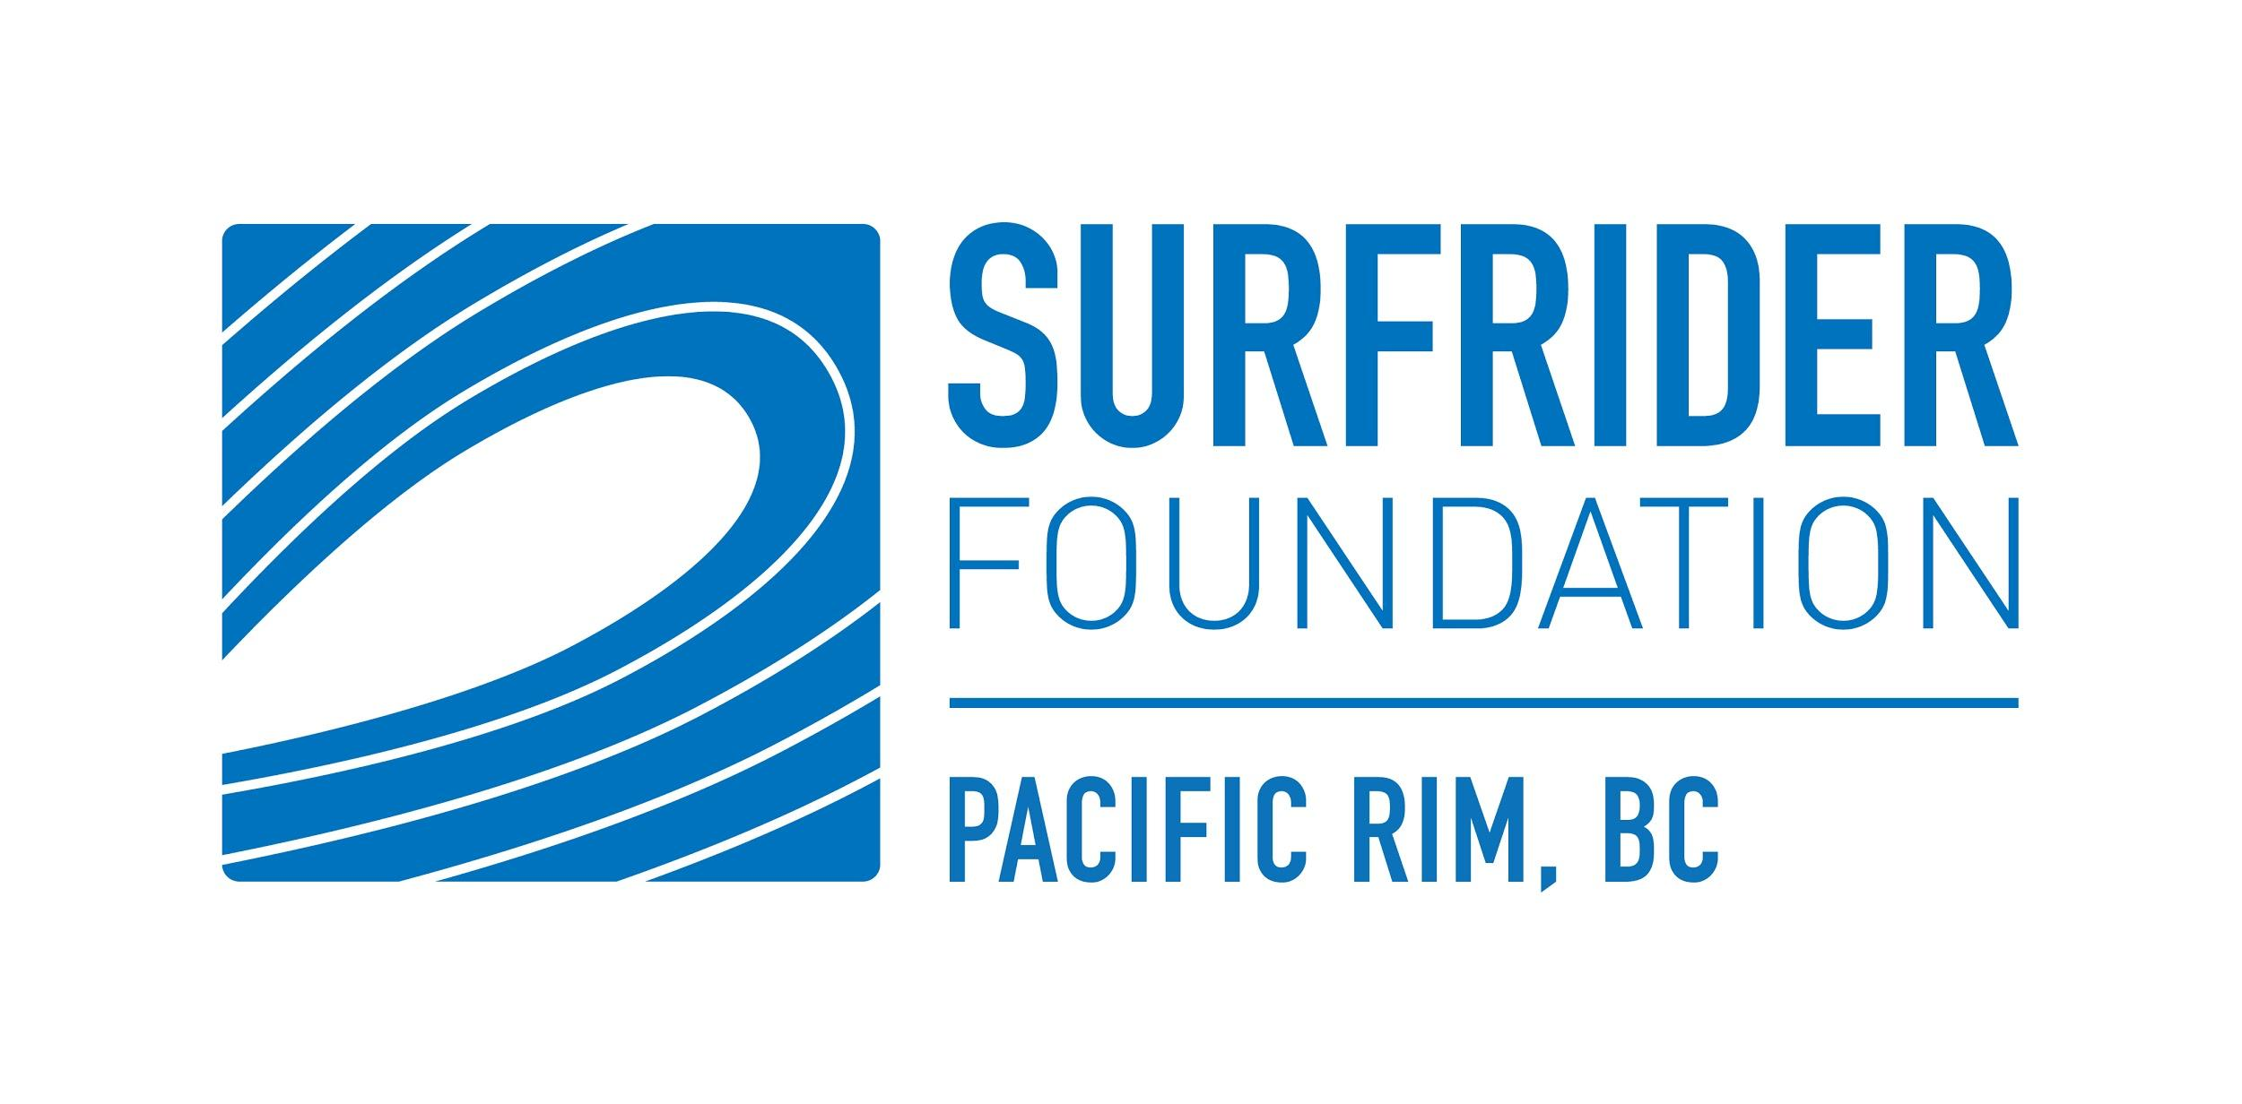
Straws Suck Pledge Sheet
I support the Surfrider Pacific Rim campaign STRAWS SUCK.
I have made a commitment to eliminate plastic straws.
I will only be giving out a biodegradable or compostable straw ON REQUEST to customers.

Date | Business Name | Printed Name of authorized representative | Signature

Surfrider Pacific Rim is a registered non-profit organization, dedicated to the protection and enjoyment of the beaches, waves and ocean through a global network of volunteers.
Visit: pacificrim.surfrider.org Email: surfriderpacificrim@gmail.com

I support the Surfrider Pacific Rim campaign STRAWS SUCK.
As a consumer I have made a commitment to say NO to plastic straws.

Date | Name | Email address | Signature

Surfrider Pacific Rim is a registered non-profit organization, dedicated to the protection and enjoyment of the beaches, waves and ocean through a global network of volunteers.
Visit: pacificrim.surfrider.org Email: surfriderpacificrim@gmail.com
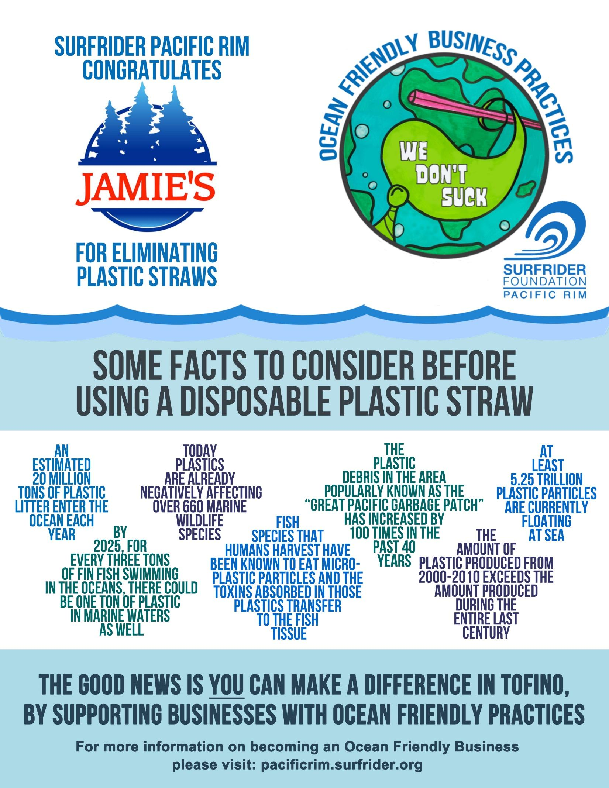
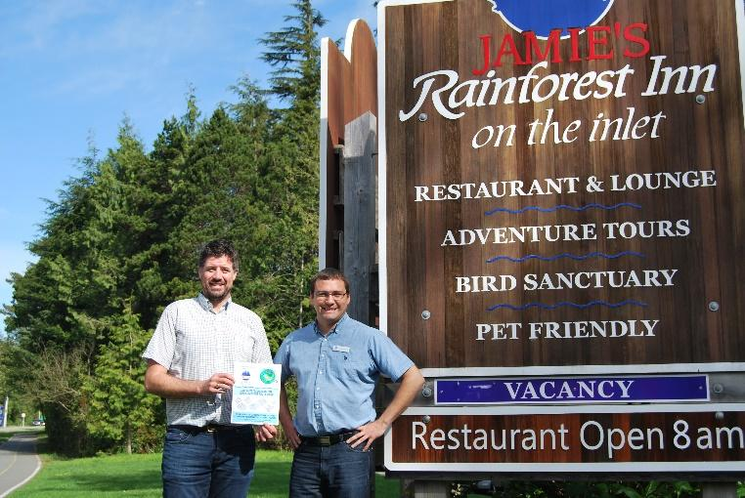

Rise Above Plastics Facts (June 2015)

- At least 5.25 trillion plastic particles are currently floating at sea.
- Producing plastic bottles for American consumption of bottled water requires 3 liters of water to produce each 1 liter of bottled water. Production of these water bottles also requires the equivalent of more than 17 million barrels of oil, not including the energy for transportation.
- By 2025, for every three tons of finfish swimming in the oceans, there could be one ton of plastic in marine waters as well.
- Over 50% of plastic entering the ocean comes from just five developing countries where there is a lack of waste management capacity.
- Plastics are already negatively affecting over 660 marine wildlife species.
- An estimated 20 million tons of plastic litter enter the ocean each year.
- Plastic debris in the area popularly known as the “Great Pacific Garbage Patch” has increased by 100 times in the past 40 years.
- Of the approximately 700,000 tons of plastic “bags, sacks, and wraps” produced in the United States, less than 5% of this is recycled, according to the EPA.
- The amount of plastic produced from 2000 - 2010 exceeds the amount produced during the entire last century.
- Fish species that humans harvest have been known to eat micro-plastic particles and the toxins absorbed in those plastics transfer to the fish tissue.

Eriksen M, Lebreton LCM, Carson HS, Thiel M, Moore CJ, et al. (2014) Plastic Pollution in the World's Oceans: More than 5 Trillion Plastic Pieces Weighing over 250,000 Tons Afloat at Sea. PLoS ONE 9(12): e111913. doi:10.1371/journal.pone.0111913
Pacific Institute Fact Sheet, 2007. http://pacinst.org/publication/bottled-water-and-energy-a-fact-sheet/
Plastic waste inputs from land into the ocean, Jenna R. Jambeck, Roland Geyer, Chris Wilcox, Theodore R. Siegler, Miriam Perryman, Anthony Andrady, Ramani Narayan, and Kara Lavender Law, Science 13 February 2015: 347 (6223), 768-771.
Plastic waste inputs from land into the ocean, Jenna R. Jambeck, Roland Geyer, Chris Wilcox, Theodore R. Siegler, Miriam Perryman, Anthony Andrady, Ramani Narayan, and Kara Lavender Law, Science 13 February 2015: 347 (6223), 768-771.
Plastic waste inputs from land into the ocean, Jenna R. Jambeck, Roland Geyer, Chris Wilcox, Theodore R. Siegler, Miriam Perryman, Anthony Andrady, Ramani Narayan, and Kara Lavender Law, Science 13 February 2015: 347 (6223), 768-771.
Raveender Vannela, Are We “Digging Our Own Grave” Under the Oceans? Biosphere Level Effects and Global Policy Challenge from Plastic(s) in Oceans, 46(15) ENVTL. SCI. & TECH. 7932, 7932 (2012).
https://scripps.ucsd.edu/news/1847
United States Environmental Protection Agency, December 2011. Web. 23 Feb 2012. http://www.epa.gov/epawaste/nonhaz/municipal/pubs/2010_MSW_Tables_and_Figures_508.pdf
Thompson, R.C. “Plastics, the environment and human health: current consensus and future trends.” Philosophical Transactions of the Royal Society B-Biological Sciences. 364.1526 (2009):2153-2166.
http://www.nature.com/srep/2013/131121/srep03263/full/srep03263.html

